Geometry: Unit 6, Lesson 13
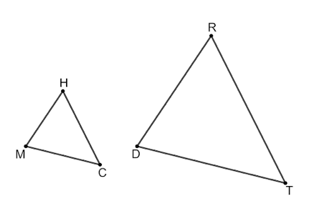
- Triangles $CMH$ and $RDT$ are shown where $CMH \sim TDR$. Given that $HM=8$, $RD=3x+1$, and the scale factor from $CMH$ to $TDR$ is $2$, solve for $x$.

$$x=5$$

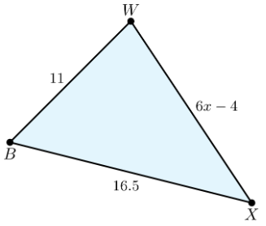

- A diagram of a triangular garden is represented. If $x=3$, what is the perimeter of $∆WBX$?

$$41.5$$

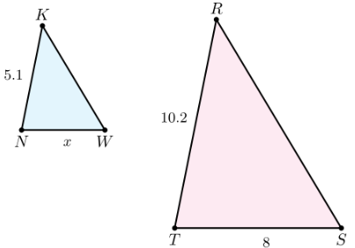
- Triangles $KWN$ and $SRT$ are shown where $∆KWN \sim ∆RST$. $KN=5.1$, $NW=x$, $ST=8$, and $RT=10.2$. What is the value of $x$?

$$4$$

